Explain Analyze Output and Summary Observations
Query:
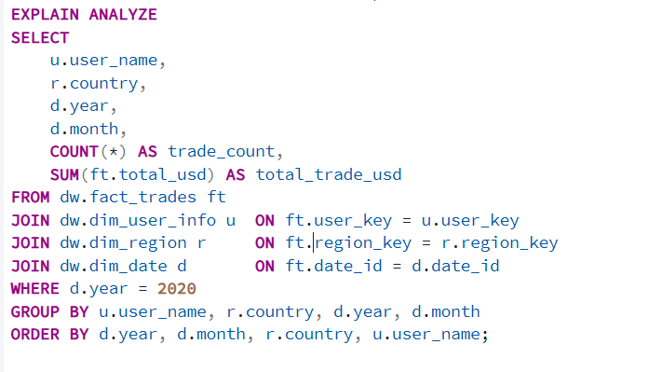

With Nested Loop Join
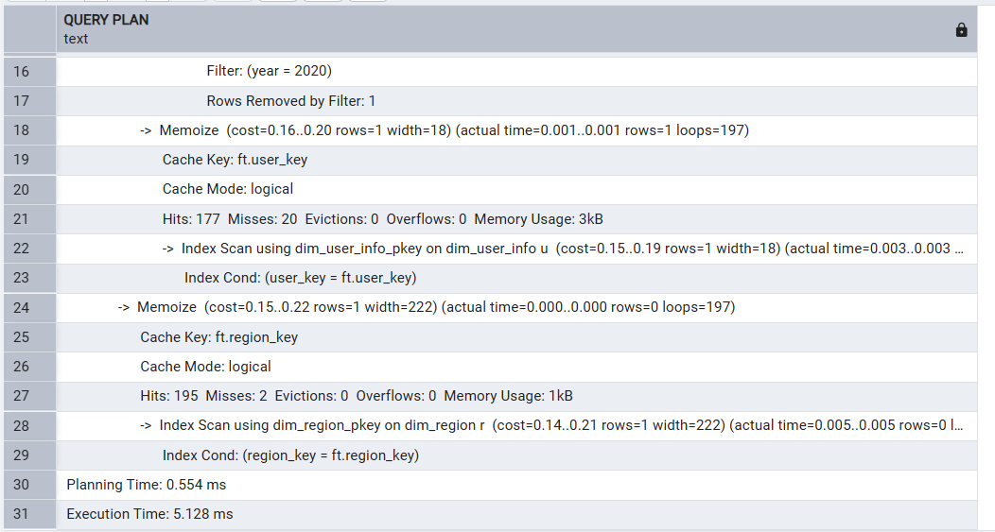

With Sort Merge Join
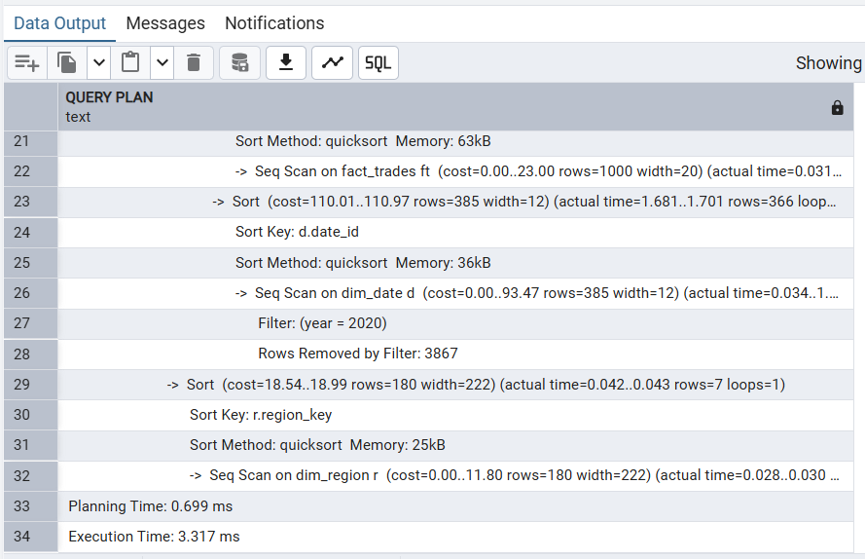
With Hash Join
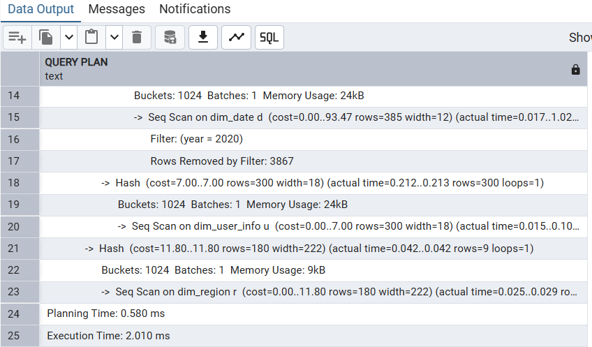

Join Type | Tables Joined | Execution Time (ms) | Observations
Nested Loop Join | fact_trades + dim_user + dim_region + dim_date | 5.128 | Good for small tables, slower on large fact data
Sort Merge Join | fact_trades + dim_user + dim_region + dim_date | 3.317 | Works well when sorted data and large sets
Hash Join | fact_trades + dim_user + dim_region + dim_date | 2.010 | Best for large DW joins. Fastest in this case

DSS Query:
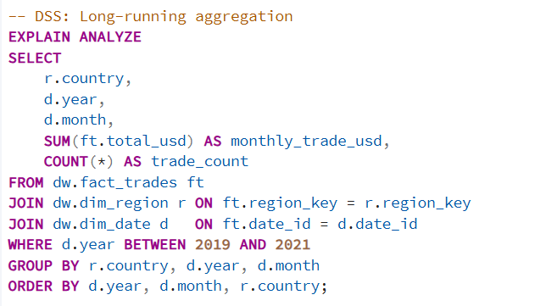

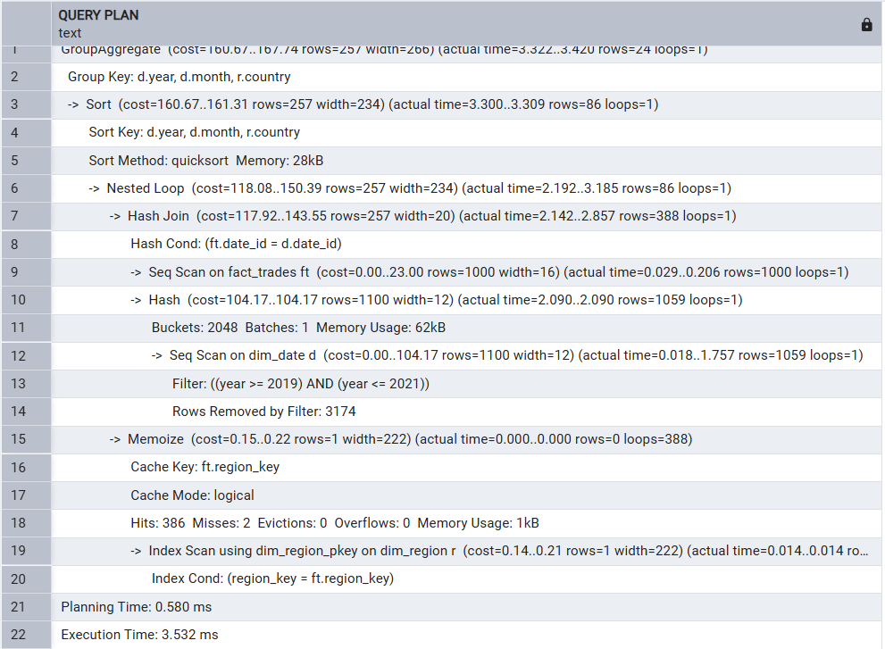
It used a Hash Join to match the large fact table with the date table, which is efficient for big data. Then it used a Nested Loop to join with the small region table, helped by an index for fast lookups. The fact table was scanned fully, which is normal for analytical (DSS) queries that work on large datasets. It also cached repeated lookups to improve performance.

OLTP Query
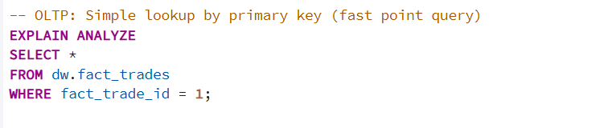
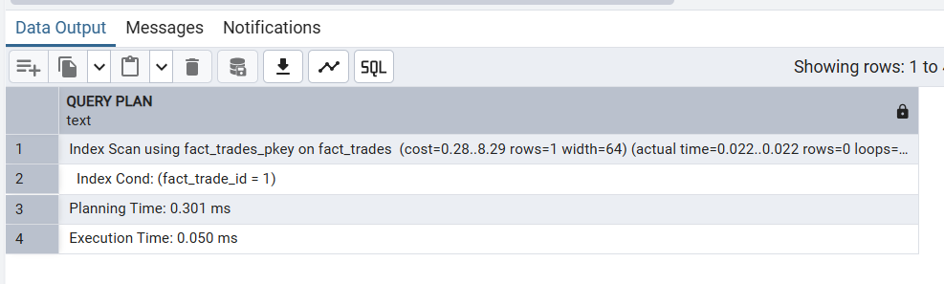
For the OLTP query, It used an Index Scan, meaning it looked up only the specific row it needed instead of scanning the whole table. This is typical for OLTP systems, where queries are small, fast, and focused on retrieving one record quickly. Because of indexing and caching, the lookup happens almost instantly.

Query Type | Tables Joined | Execution Time | Joins Observed
DSS | fact_trades + dim_user_info + dim_region + dim_date | 3.532 | Hash Join + Nested Loop + Index Scan
OLTP | dim_user_info | 0.050 | Index Scan

